

**MAHARASHTRA STATE BOARD OF TECHNICAL EDUCATION, MUMBAI**

### **A Report on**

**Industrial Training**

### **(Internship)**

### **(22057)**



**Computer Engineering Programme**

Shri Shivaji Vidya Prasarak Sanstha’s

Bapusaheb Shivajirao Deore Polytechnic– Dhule.

Institute Code: 0059

**2023-2024**



**MAHARASHTRA STATE BOARD OF TECHNICAL EDUCATION,**

**MUMBAI**

# Certificate of Completion

### of Industrial Training

This is to certify that,

|  |  |  |
| --- | --- | --- |
| **Sr. No** | **Enrolment Number** | **Name of Student** |
| 1. | 2100590064 | Deore Samarthya Ravindra |
| 2. | 2100590071 | Gangurde Suprabha Dinesh |
| 3. | 2100590079 | Jain Ekta Vinod |
| 4. | 2100590102 | Makhija Dhruv Harish |
| 5. | 2100590135 | Patil Rasika Sunil |

have successfully completed Industrial Training (22057) at InnovationsHub Services Pvt Ltd **.** From 04th July 2022 to 14th Aug 2022 _(6 weeks) for partial fulfillment towards completion of Diploma in **Computer Engineering** from S.S.V.P.S’s B. S. Deore Polytechnic, Dhule.

(Institute Code: **0059**).

**Mr. C. P. Bhamare Ms. S. H. Patil**

**Mentor Head**

**Prof. P. B. Kachave**

**Principal**

**Certificate from Industry**

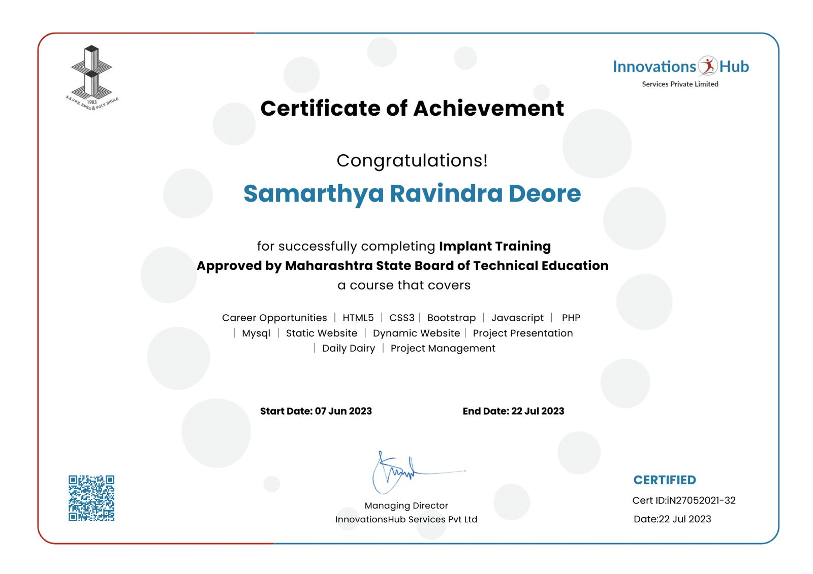

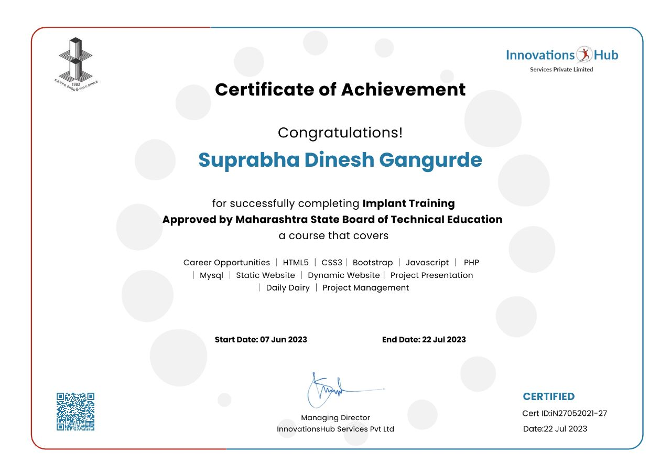

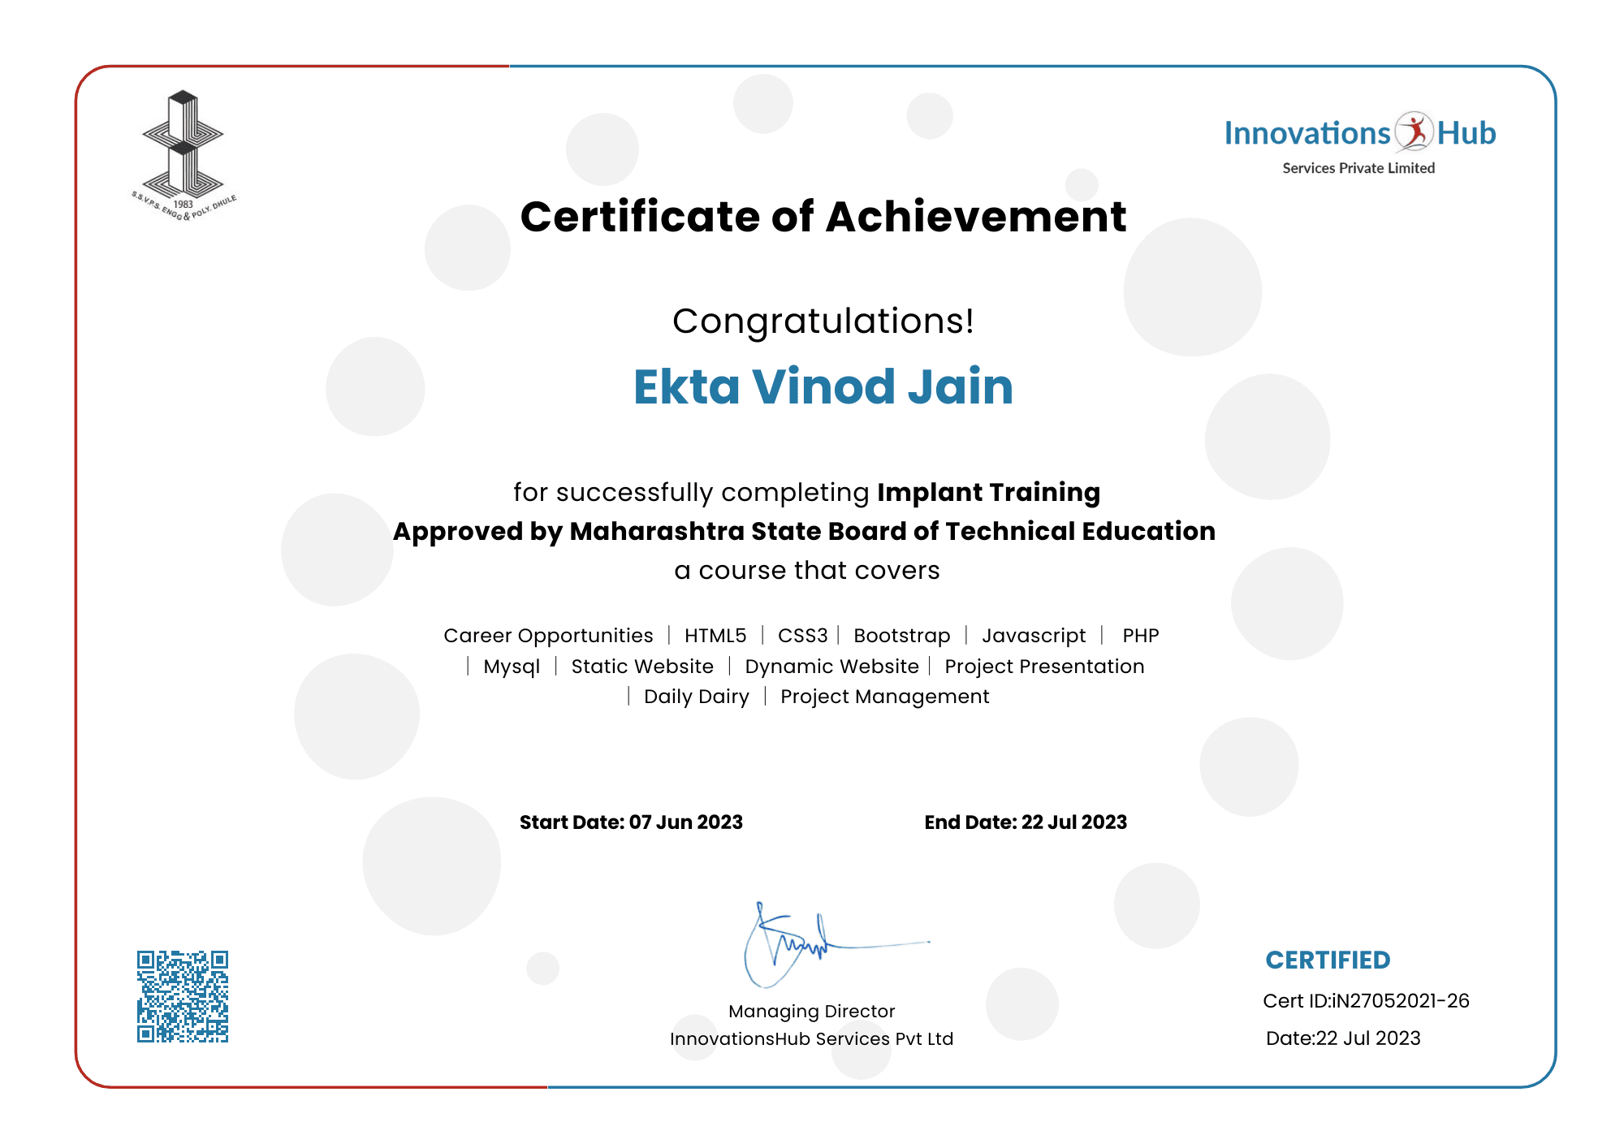

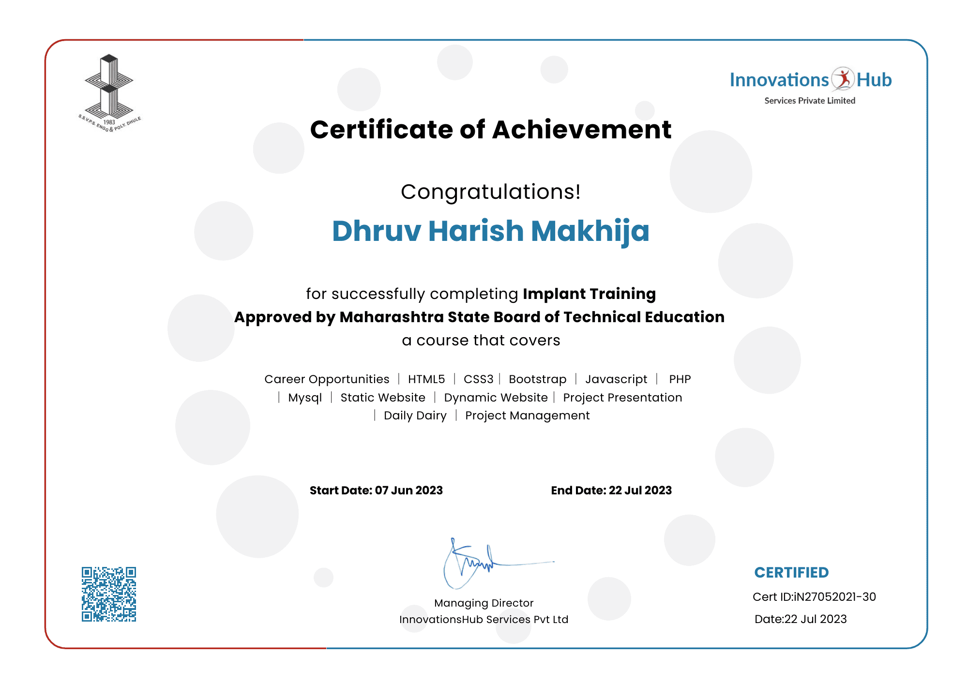

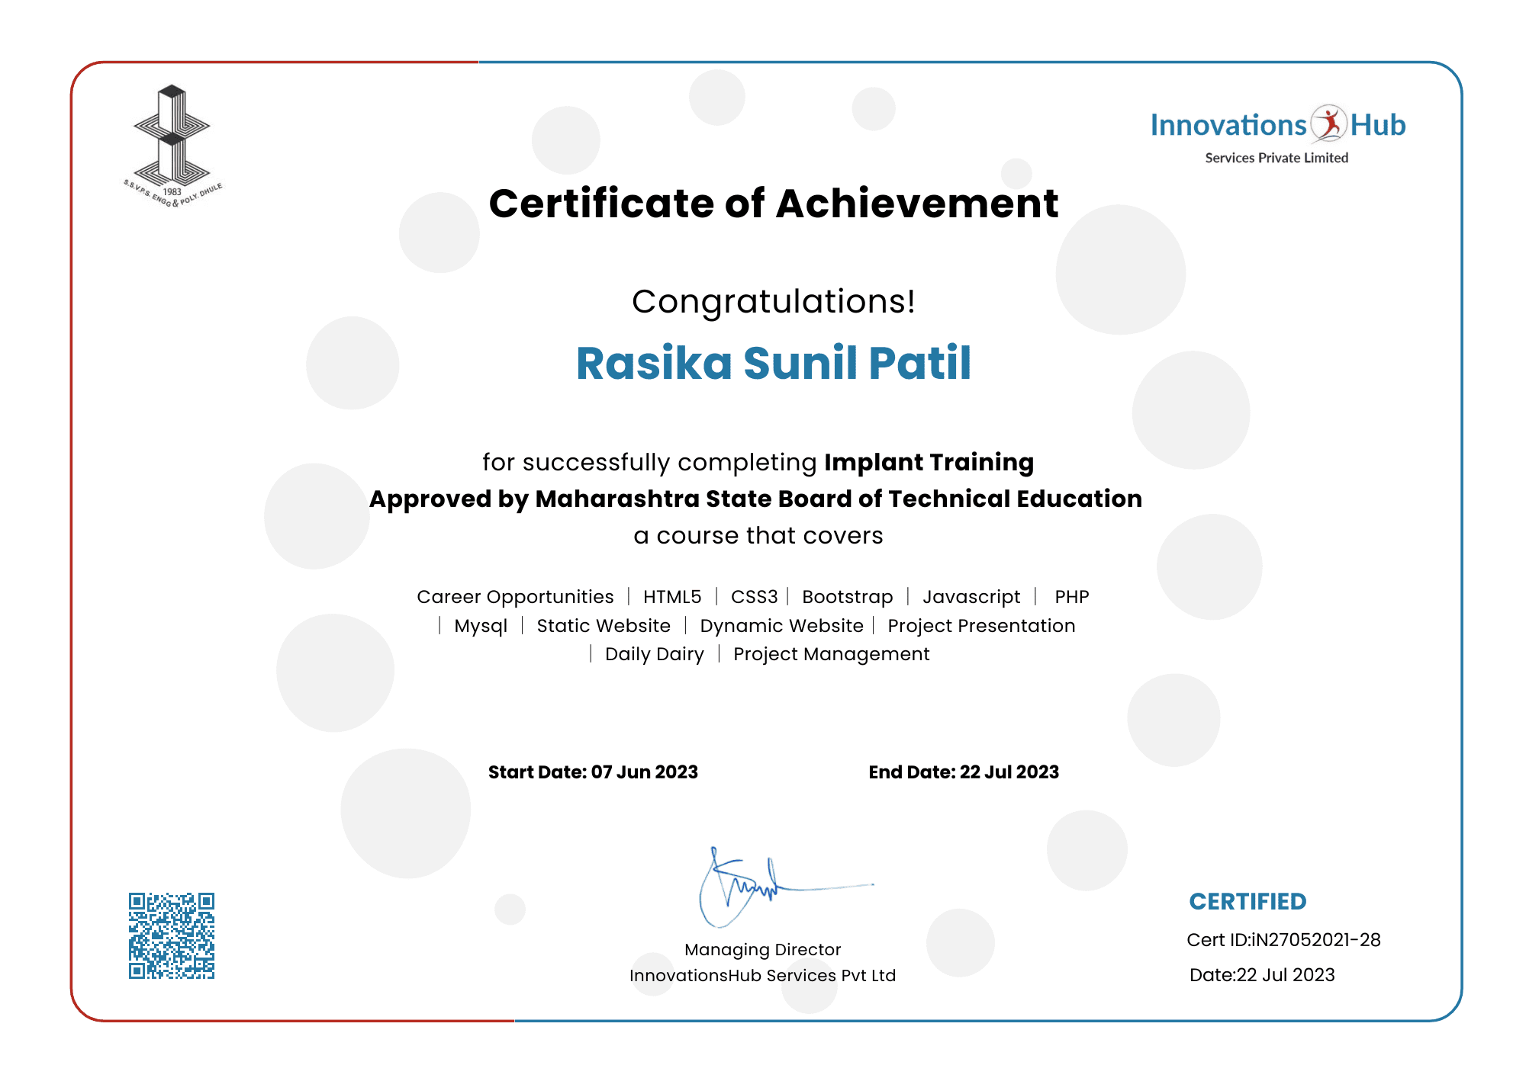

**Abstract**

This abstract presents a dynamic shoe website developed using a robust stack of technologies including HTML, CSS, Bootstrap, JavaScript, and PHP. The website features an interactive admin panel, a user panel, as well as efficient login and sign-up forms to enhance the overall user experience.

The website's core design principles revolve around providing a seamless and visually appealing interface, ensuring easy navigation, and facilitating efficient management of both user and product data. The frontend of the website has been crafted using HTML, CSS, and Bootstrap, resulting in a responsive design that adapts to various screen sizes, from desktops to mobile devices. The website's login and sign-up forms are equipped with robust authentication mechanisms, protecting user data and safeguarding against unauthorized access. This security measure enhances user confidence and trust in the platform.

In conclusion, this dynamic shoe website showcases the seamless integration of HTML, CSS, Bootstrap, JavaScript, and PHP, resulting in an engaging and user-friendly footwear shopping platform. The incorporation of an admin panel and a user panel, along with secure login and sign-up forms, sets the stage for a successful e-commerce venture, providing customers with a delightful shopping experience while empowering administrators with the tools to manage the platform efficiently

**Acknowledgment**

We hereby take this opportunity to express our gratitude towards the people whose help is very useful in completing our project “E-Shop (Shoe Website)”.We would like to express our thanks to our guide Mr. C. P. Bhamare whose guidance become very valuable for us. We are also very thankful to our head of department, Ms. S. H. Patil for providing precious help and advice. Finally, we would like to thank all our friends and well-wishers who have a very important role in nurturing and strengthening our careers.

Yours Sincerely,

Deore Samarthya Ravindra

Gangurde Suprabha Dinesh

Jain Ekta Vinod

Makhija Dhruv Harish

Patil Rasika Sunil

**Chapter 1**

**Introduction**

* 1. **Introduction.**

Welcome to the Industrial Training Course in Web Development! In this comprehensive program, we have explored HTML, CSS, Bootstrap, JavaScript, and PHP, the fundamental building blocks of modern web development. Throughout this journey, you have acquired they abilities to create visually captivating and interactive websites that not only engage users but also deliver seamless user experiences. From crafting elegant layouts with HTML and CSS to enhancing responsiveness with Bootstrap. Moreover, JavaScript has empowered you to create dynamic and interactive elements, bringing life to your web projects. The integration of PHP has enabled you to develop robust server-side functionalities. However learning is not complete without practical application. As part of this training, you have taken your newly acquired knowledge and put it into action by creating our very own website. From conceptualization to implementation, you have sharpened your skills by building a functional website, showcasing your skill in web development.

**1.2 Objectives of Implant Training.**

* Develop skills in analyzing the usability of a website.
* Understand how to plan and conduct user research related to web usability.
* Learn the language of the web: HTML and CSS. Assignments solved/Projects developed

**Chapter 2**

**Company’s Profile/Background**

* 1. **Introduction of Industry / Organization:-**

1. **COMPANY/ INDUSTRY PROFILE:-**

* **Name of the Company**: InnovationsHub Services Pvt Ltd
* **Location/ address** /**Pin code**: Reg. Office : 49, Vakratund Bungalow, Amrutdham, Nashik-422003, India
* **Establishment**: 2018
* **Email & Web Address**: www.innovationshub.in
* **Name and Designation of Owners / Contact Person:** Sachin Patil (Director)
* **Contact Number of Owners / Contact Person:** 9021721618
* **Type of Product:** Service Industry
* **Type of Control:** (Private)
* **Type of Company:** NA
* **Total Number of Employees in Company:** 22
* **Total Turnover of Company:** NA

**2.2 Type of Products and Services:**

Websites, Mobile Applications, ERP, E-commerce, Online Marketing Animation, Commercial Billing Software

**2.3 History:-**

Winner of the Smart India Hackathon 2022 (project-sponsored), organized by the Ministry of Education (MoE).

* InnovationsHub creates technology solutions for retailers and commercial businesses to improve customer profitability.
* Develop POCs to test out new technologies and solutions.
* Industry Expertise: Healthcare, API Banking, Retail, Research, and Development.

**Technology Highlights:**

* + Cloud Platforms (SaaS | Cloud SQL | Cloud Storage)
  + Data Modelling, NoSQL, and Relational DBs
  + Web Services, Portals and Dashboards.
  + Mobile Apps and Experiences (Android | Cloud)
  + Digital Marketing(SEO | Social Media)
  + Training and Internship(Web | Android | Java | Python | AWS | Automation)

**2.5 Types of Major Software used in Industry/Organization with their specification:**

**1. Laptops:**

**Specification**

Processor: up to Intel Core i5-2410M 2.3 GHz.

* Graphics: ...
* Memory: up to 8GB DDR3.
* Storage: up to 750GB hard disk drive.
* Optical Drive: a dual-layer DVD reader/writer.
* Display: 17.3" (HD, maximum resolution of 1600 × 900)
* Web Camera: integrated.

**2. Notepad++**

* Notepad++ is a free, open-source text and source code editor. Written in the Web language, Notepad++ prides itself in paring down on unnecessary features and streamlining processes to create a light and efficient text notepad program.

**3. Local Server**

* XAMPP is a free and open-source cross-platform web server solution stack package developed by Apache Friends, consisting mainly of the Apache HTTP Server.

**2.5 Organization Chart:**

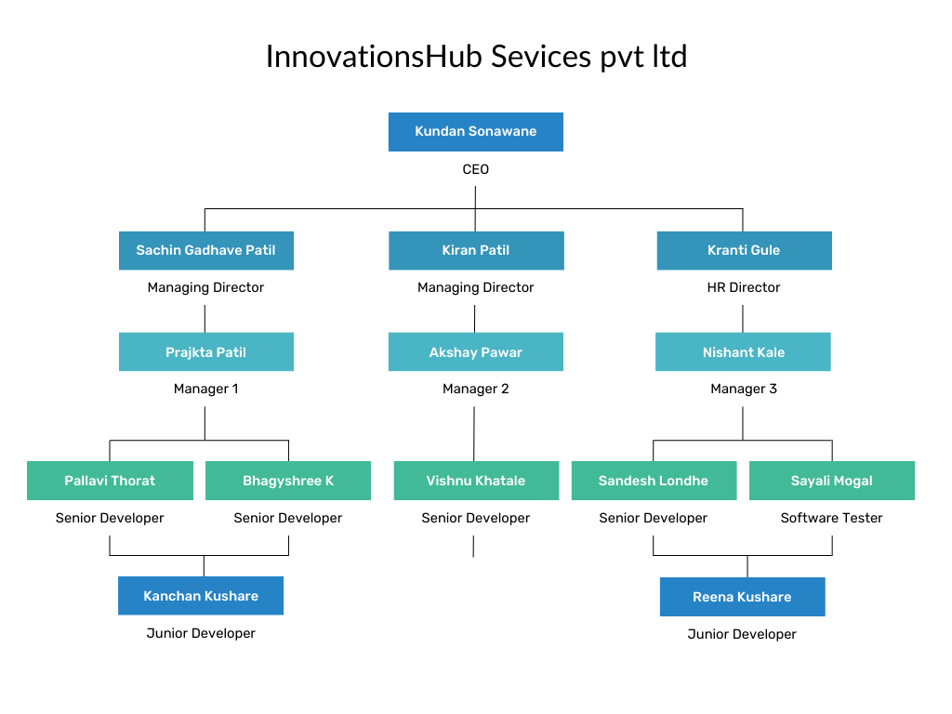

**Chapter 3**

**Weekly Job Summary**

**Week 1:**

In this week we first learned the difference between static and dynamic. Additionally, we learned how to add Google Maps, audio, and video to websites. Also created a form with the use of a button, label, etc.

**Week 2:**

We learned anchor tag and text formatting concepts also fundamentals of CSS in this week. We have also learned color properties and background properties. We have also design a basic Website using Header, Article and Footer

**Week 3:**

In this week we have learned Text-align, Text-Transform, and Text-Decoration properties. Margin properties including Padding, Dimension etc.

We have also learned fundamentals of in Bootstrap in week. Href tag concepts of various classes, Grid system, Jumbotron class and Type of Tables.

**Week 4:**

We have learned concepts of Bootstrap like alerts, Button class, form, various Button groups and progress bars. We learned various columns development and Symbols (glyphicon). We developed assignment using Header, Article and Footer using Bootstrap.

**Week 5:**

We learned fundamentals of Javascript and To change HTML content, to change CSS object, change HTML object, Form- validation, etc. To use variables to store values , datatypes and rules for creating variables. We performed Assignment - Change background color using radio buttons.

**Week 6:**

We have learned operators, statements, and functions. Fundamental of PHP and Installation Local and Live server and Client server architecture also conditional statement and loops in PHP. How to download, install and operate Xampp server also run PHP programs using local host.

# Week 1: From: 7 / 6 /2023 to 13 / 6 /2023

|  |  |
| --- | --- |
| **Day** | **Activities carried out** |
| 1 | * Web Design & Development. (Static and Dynamic Websites) * Introduction to HTML (hypertext markup language), Version upgradation, HTML structure. * Page Components: |
| 2 | * <!doctype html> Declaration of version HTML * <html> Container for the document </html> * <head><title> Title of the web page. </title></head> * <body> Content of the web page<body> * Heading tags (h1, h2, h3, h4, h5, h6) H1 – larger, H6 – smaller. * Paragraph tag :<p></p> |
| 3 | * Image tag <img src = “url” alt = “description of Image”> * src: attribute where we can specify path of image. * alt: attribute where we can specify alternative name for image when image cannot be display. |
| 4 | * Ordered list <ol></ol> Unordered list <ul></ul> List tag <li></li> * Table tag <table></table> * <tr></tr>indicates table row. * <td></td>indicates table data. * Grouping tag: <div></div> |
| 5 | * Form: * Input tag :<input type=”text” placeholder=”name”> * type=”text” means it contains text value and placeholder * type=”radio” used for radio buttons, type=”checkbox” used for checkbox, * type=”submit” used to submit form. |
| 6 | * Used to insert a Div in an Html structure. * Assignment-Basic website Page. |

# Week 2: From: 14 / 6 /2023 to 20 / 6 /2023

|  |  |
| --- | --- |
| **Day** | **Activities carried out** |
| 1 | * Anchor tag <a></a> * Target attribute used to open link in new tab or the same to redirect in same tab. * target= “_self” * To redirect in new tab. * target=“_blank” |
| 2 | * Text Formatting : * Horizontal line tag <hr> * It is singular tag used to add horizontal line. * Bold tag <b> </b> Used bold text. * Super-script tags <sup></sup> * Sub-script tags <sub></sub> |
| 3 | * Introduction to CSS (Cascading style sheets) * Rules and types of CSS (Inline, Internal, External) |
| 4 | * Way of defining CSS: * Using Tag name: Use when we have only one tag. (e.g.: p{color: red;}) * Using Id: we use ‘#’ to write CSS for id. (e.g.: #name{height:50px;}) * Using Class name: we use ‘.’ To write CSS for class. (e.g.: .head{color: black;}) |
| 5 | * Color (color: “color name” ;) * Background Type: * background-color: “color name”; * background-image: url(“src”); * background-repeat: repeat-x, repeat-y, or no-repeat. |
| 6 | * Assignment-Design first website using Header, Article and Footer. |

# Week 3: From: 21 / 6 /2023 to 27 / 6 /2023

|  |  |
| --- | --- |
| **Day** | **Activities carried out** |
| 1 | * Text: font-size, font-family, font-style, text-shadow. * Text-align (Center, Right, Left, Justify) * Text-transform (Uppercase, Lowercase, Capitalize) * Text-decoration (none, underline, overline, line-through) |
| 2 | * Display: inline, block, inline-block, none. * Dimensions: width, height. * Overflow: hidden, scroll, visible, auto. Border: Parameters: Border-size, Border-style (dashed, solid, dot), Border-color.   (e.g.: “border: 2px solid color;”) |
| 3 | * Margin: outer space of content (margin: dimensions ;) * Padding: inner space of content (padding: dimensions ;) * Dimensions: top, right, bottom, left Same for both. |
| 4 | * Introduction to Bootstrap. * Online-bootstrap:<link rel="stylesheet"href="https://maxcdn.bootstrapcdn.com/bootstrap/3.4.0/css/bootstrap.min.css"> * Offline bootstrap: (download bootstrap file and include it in tag) |
| 5 | * Classes: Container and Container-fluid. * Grid: Grid is made up of grouping of Rows and Columns inside 1 or more Containers. * Used for layout, specifically Responsive Layouts. |
| 6 | * Jumbotron class: used to create a grey box. * Table class: table class = “table”. * table-bordered, table-striped, table-condense, table-responsive. * Image-classes: img-rounded, img-thumbnail, img-responsive, img-circle. |

# Week 4: From: 28 / 6 /2023 to 4 / 7 /2023

|  |  |
| --- | --- |
| **Day** | **Activities carried out** |
| 1 | * Alerts: alert-success, alert-info, alert-warning, alert-danger. * Input: input-group, input-group-addon. * Input-size: lg(Large), sm(small), md(Medium), xs(Extra small). |
| 2 | * Button class: btn btn-default, btn btn-success, btn btn-danger, btn btn-info, btn btn- * warning, btn btn-link, btn btn-primary. |
| 3 | * Form: form-control, form-group. * Columns: col-lg-6/12, col-xs-12/6, col-sm-4/6, col-md-4/6. * Symbols: glyphicon (envelop, search, etc.) |
| 4 | * Button primary class: active, disabled. * Button-group: btn-group, caret (used to create selectbox). * Dropdown-menu: dropdown-menu (to create listbox |
| 5 | * Progress: class progress-bar. * Progress-bar-success, progress-bar-info, progress-bar-warning. progress-striped, * progress-stripped-active |
| 6 | * Assignment-Design first website using Header, Article and Footer using Bootstrap |

# Week 5: From: 5 / 7 /2023 to 11 / 7 /2023

|  |  |
| --- | --- |
| **Day** | **Activities carried out** |
| 1 | * Introduction to JavaScript * Applications: To change HTML content, to change CSS object, change HTML object, * Form- validation, etc. |
| 2 | * Display Possibilities : * Using .innerHTML * document. write() * window. alert() * console.log() * Script tag: <script type=css/javascript></script> * Method: document.getElementById();` |
| 3 | * Change Html content. innerHTML used to change html content. * Change CSS content. * style used to change CSS content |
| 4 | * .src used to perform action on image. * .style used to change CSS object. * Hide: .style. display=’none’ (Hide the Content.) * Show: style=”display: none”(When onclick event happen show the Content.) |
| 5 | * Variable: * Used to store values. var used to assign name. * Rules of creating variable. * Data types. |
| 6 | * Assignment- Change background color using radio buttons |

# Week 6: From: 12 / 7 /2023 to 22 / 7 /2023

|  |  |
| --- | --- |
| **Day** | **Activities carried out** |
| 1 | * Arithmetic operators. Assignment operators. Bitwise operators. Logical operators (AND (&), OR (|), NOT (!)). |
| 2 | 1. Statements: 2. if, if-else, if…else if 3. Form-validation and Function |
| 3 | 1. PHP Introduction and 2. Installation Local and Live server 3. Client server architecture |
| 4 | 1. Introduction To php and how to download , install and operate Xampp server. 2. Also run php programs using local host. 3)Structure of php program and some basics Ex:-<?php 3. $t=date(“H”); 4. If($t<”20”){   Echo “Have a good day!”; } ?> |
| 5 | 1. 1) if(condition){   Code to be executed if condition is true; }   1. if(condition){   Code to be executed if condition is true}  else{  Code to be executed if condition is false; }   1. switch |
| 6 | 1. While (condition is true) {   code to be executed; }   1. do while do {   code to be executed;  } while (*condition is true*);   1. for (init counter; test counter; increment counter)   {code to be executed for each iteration;} |

**Chapter 4**

**Technical Contents / Report**

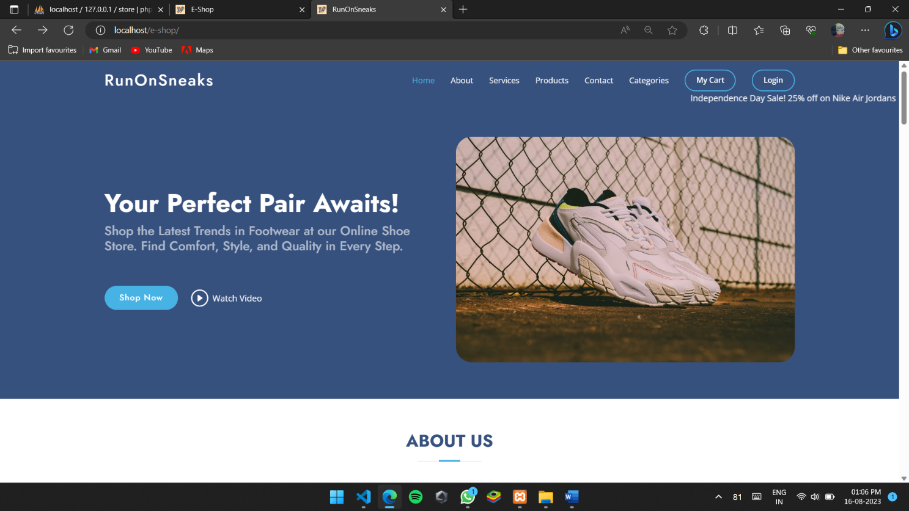

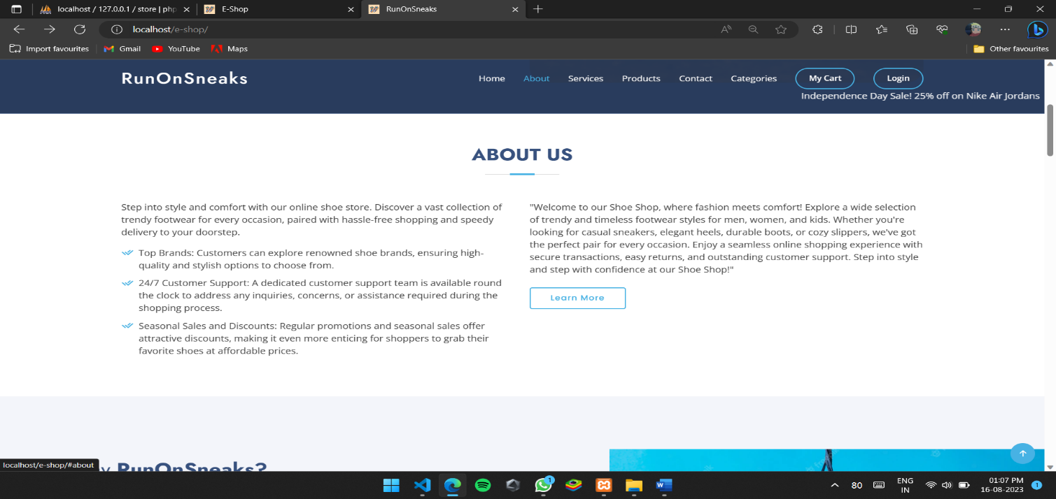

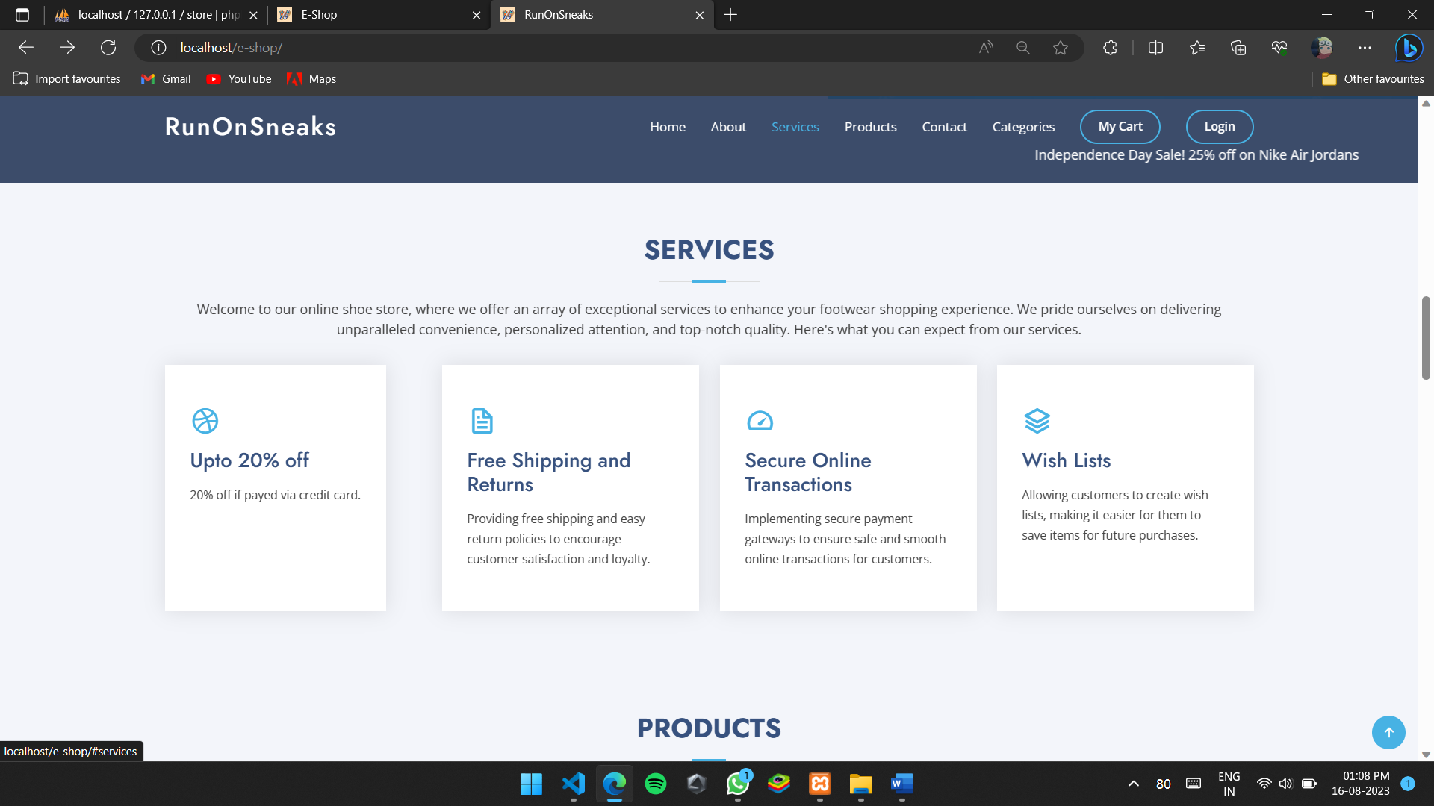

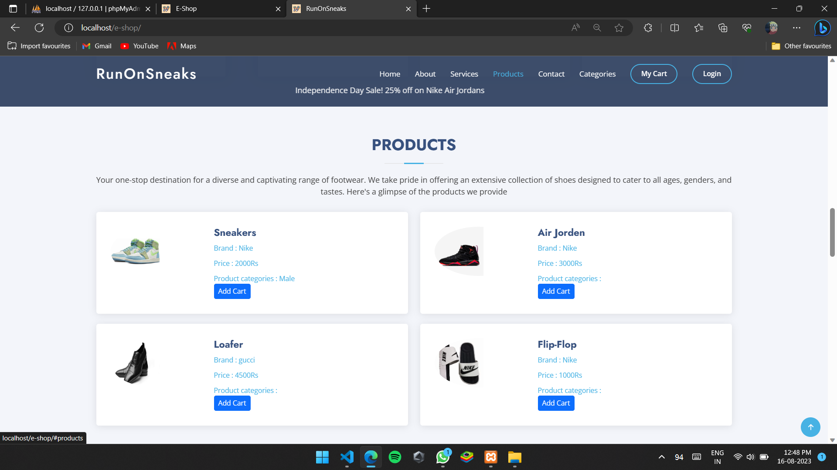

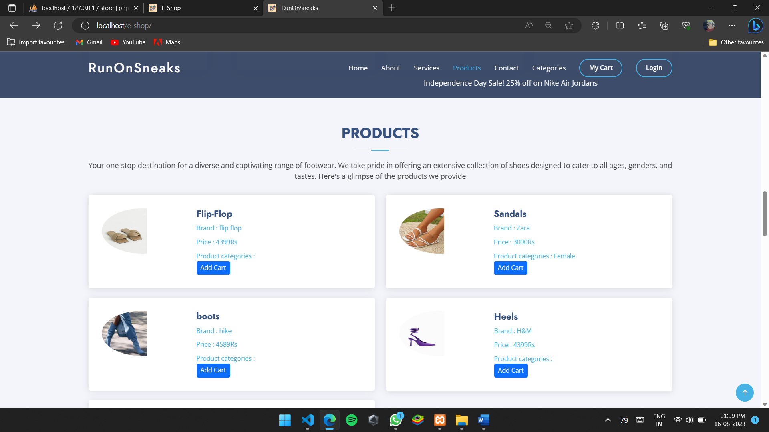

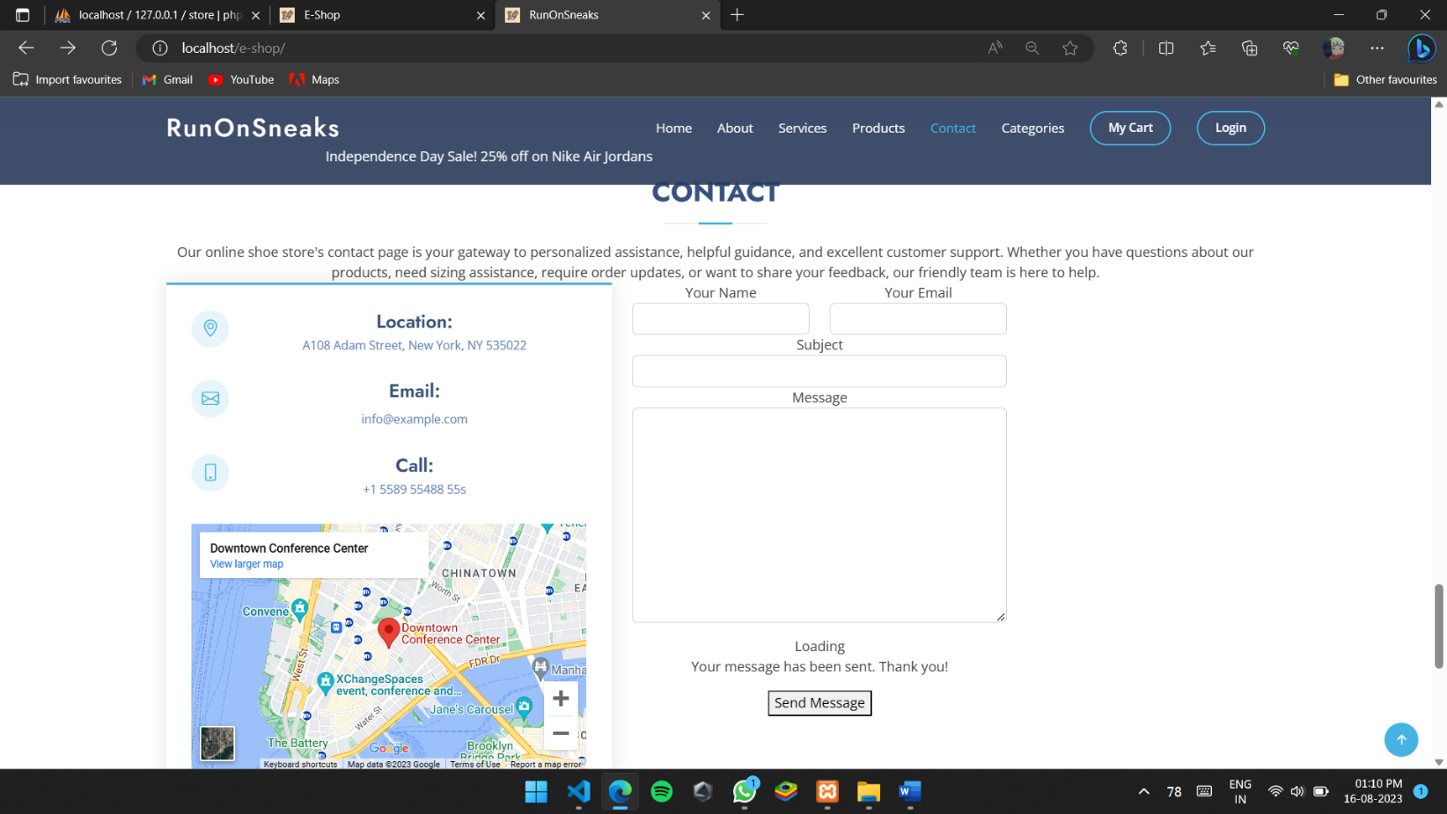

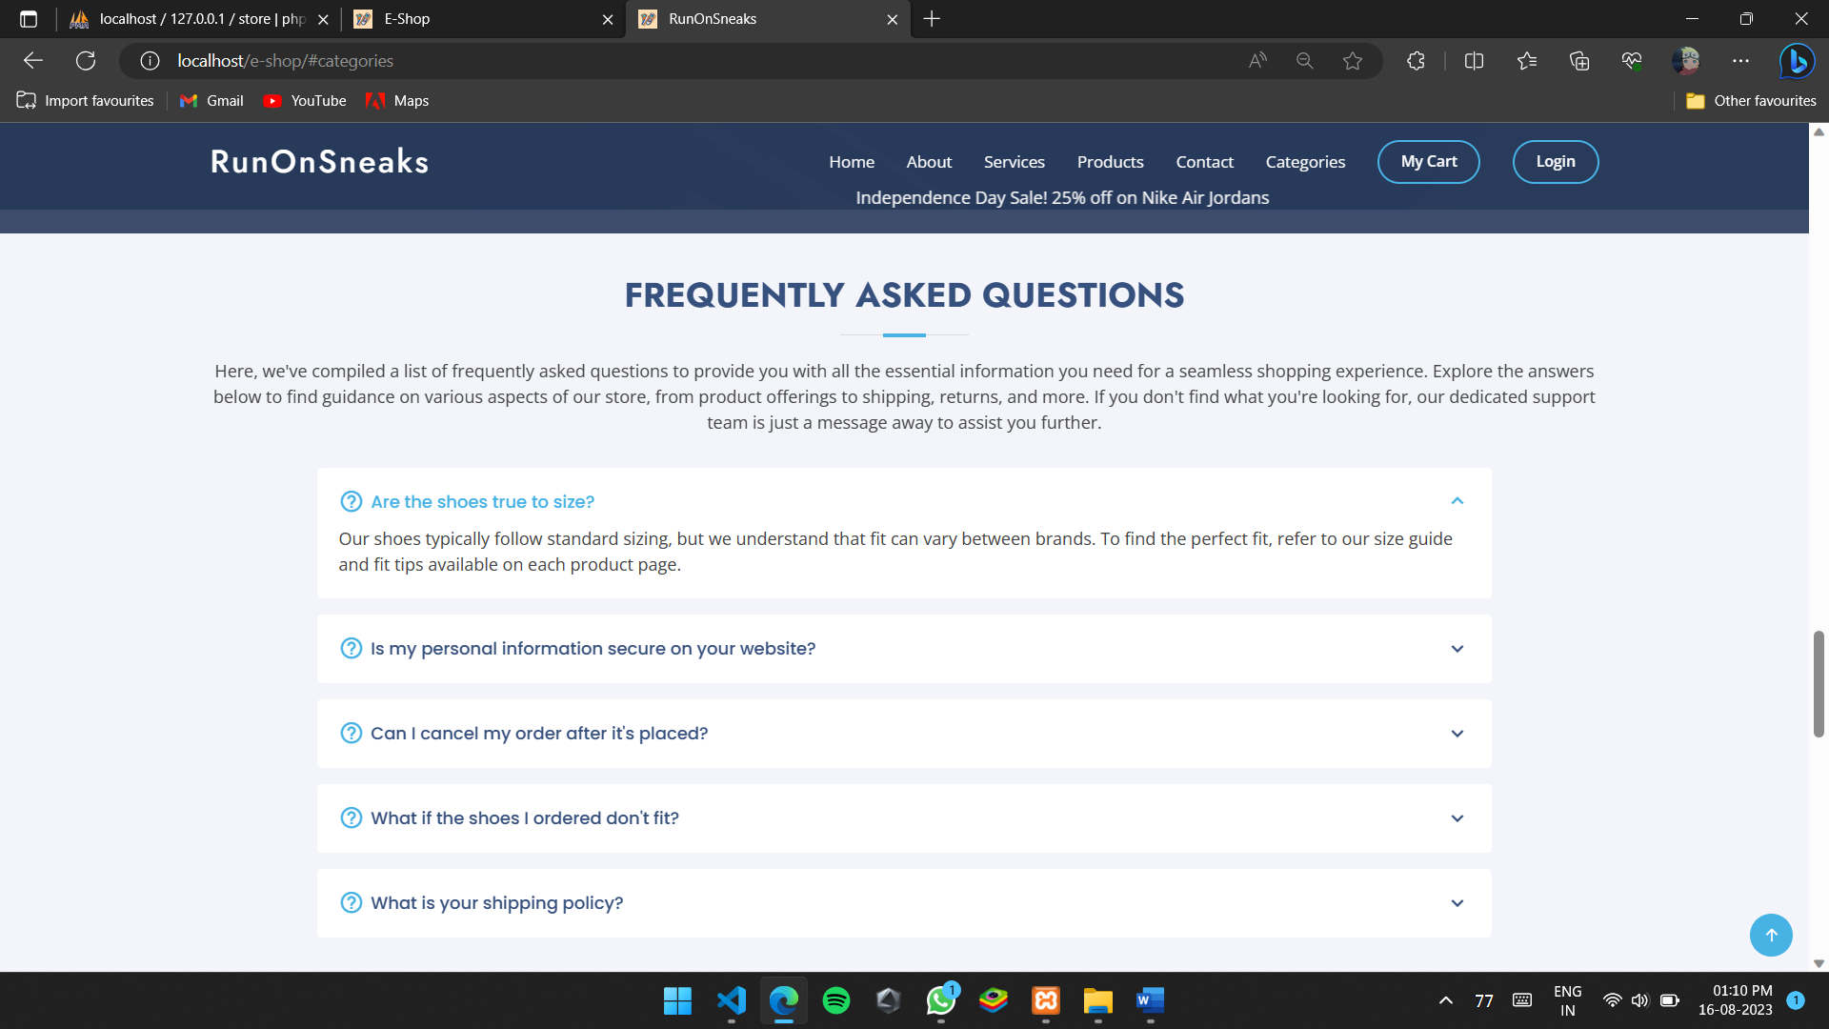

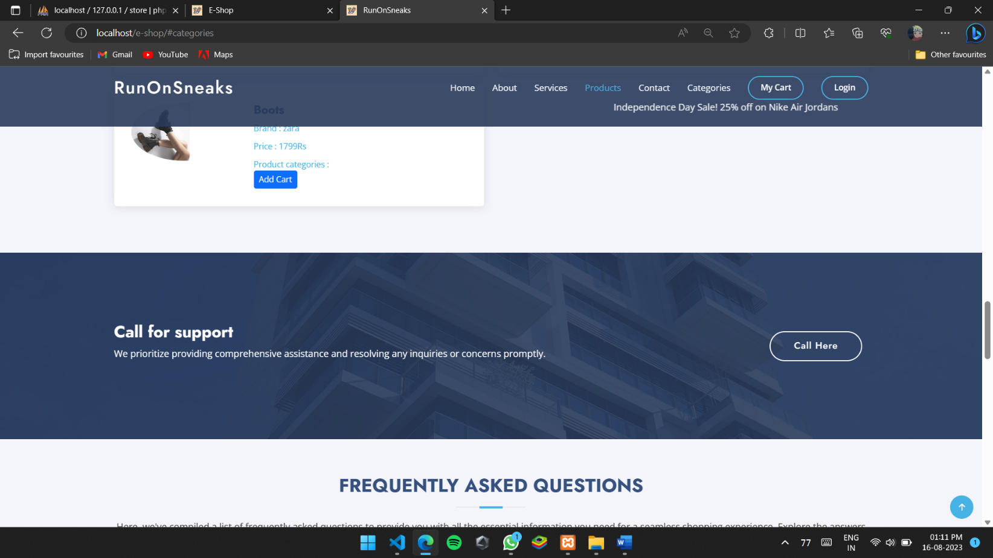

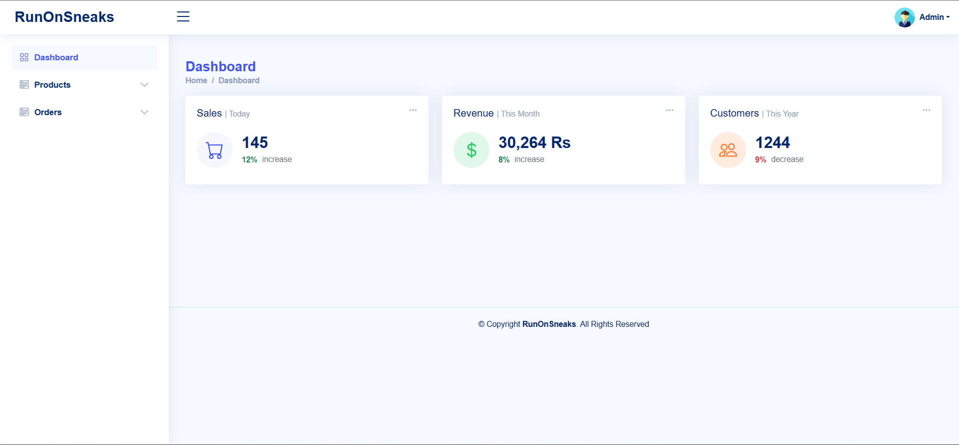

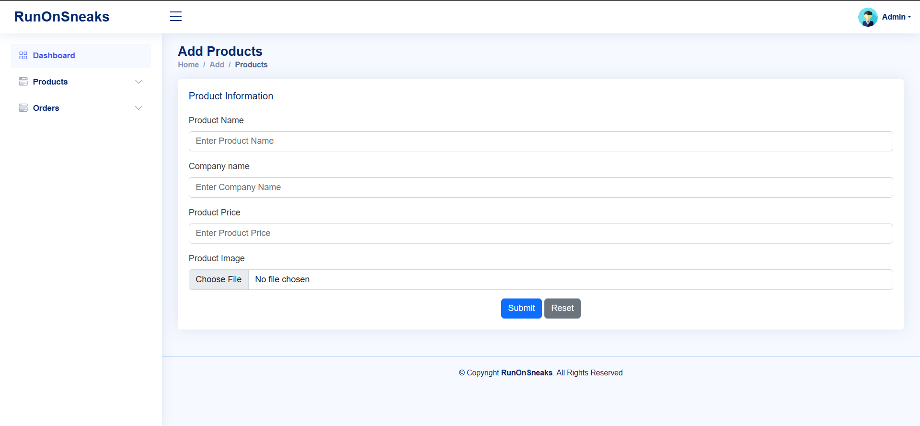

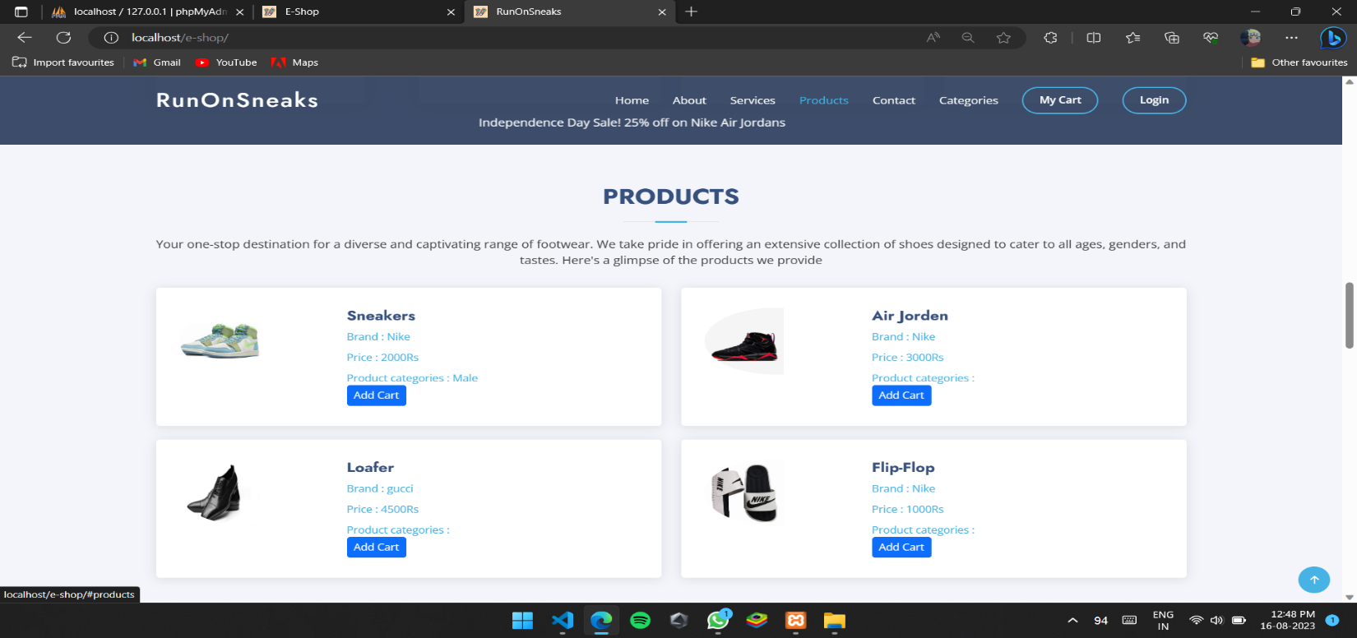

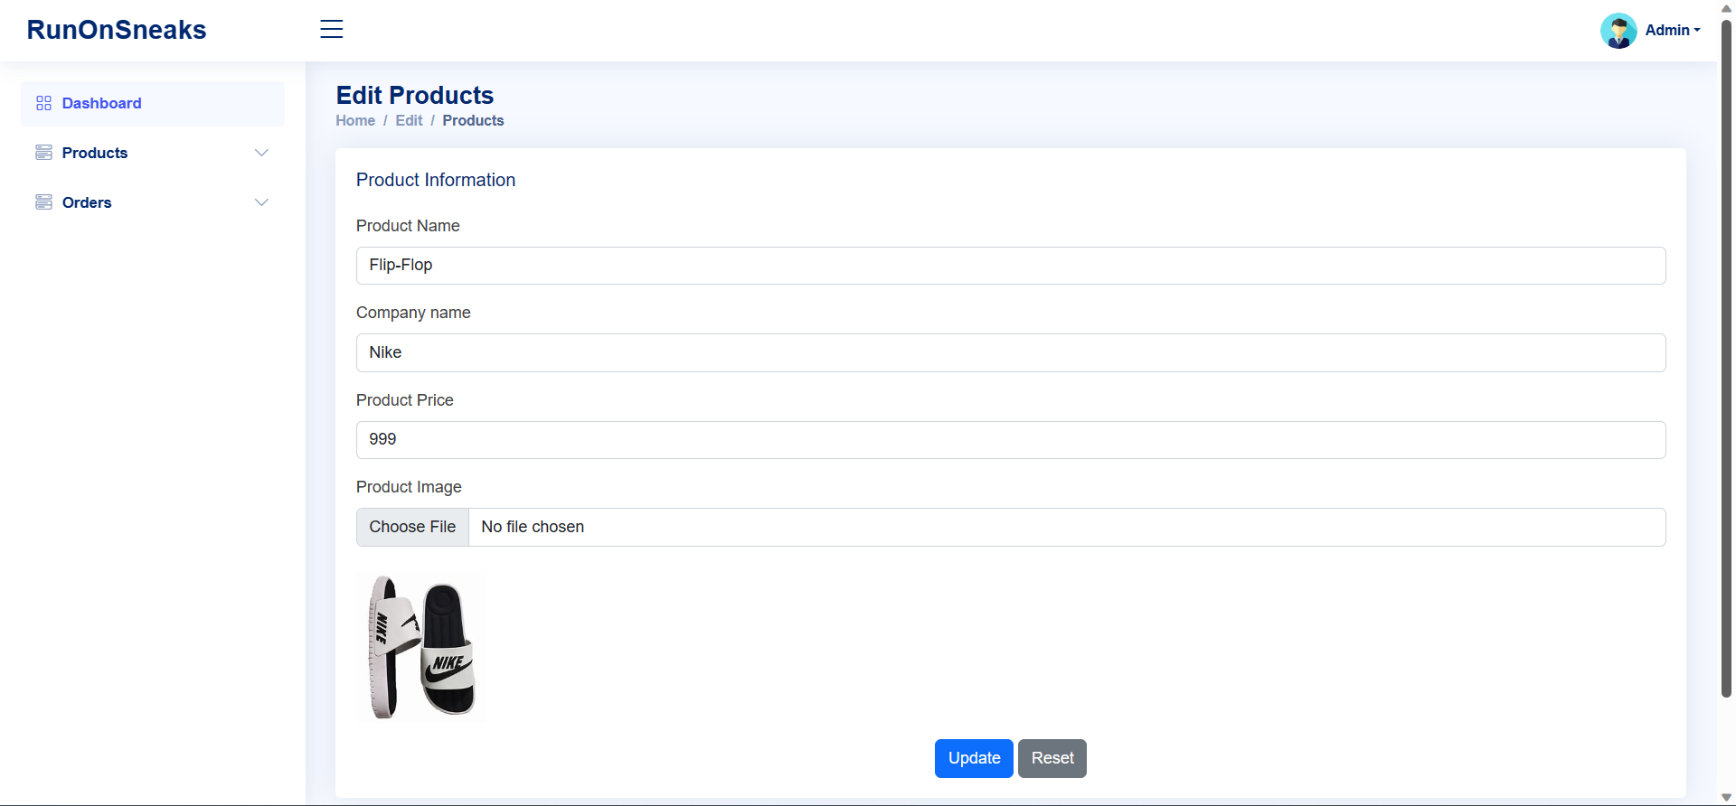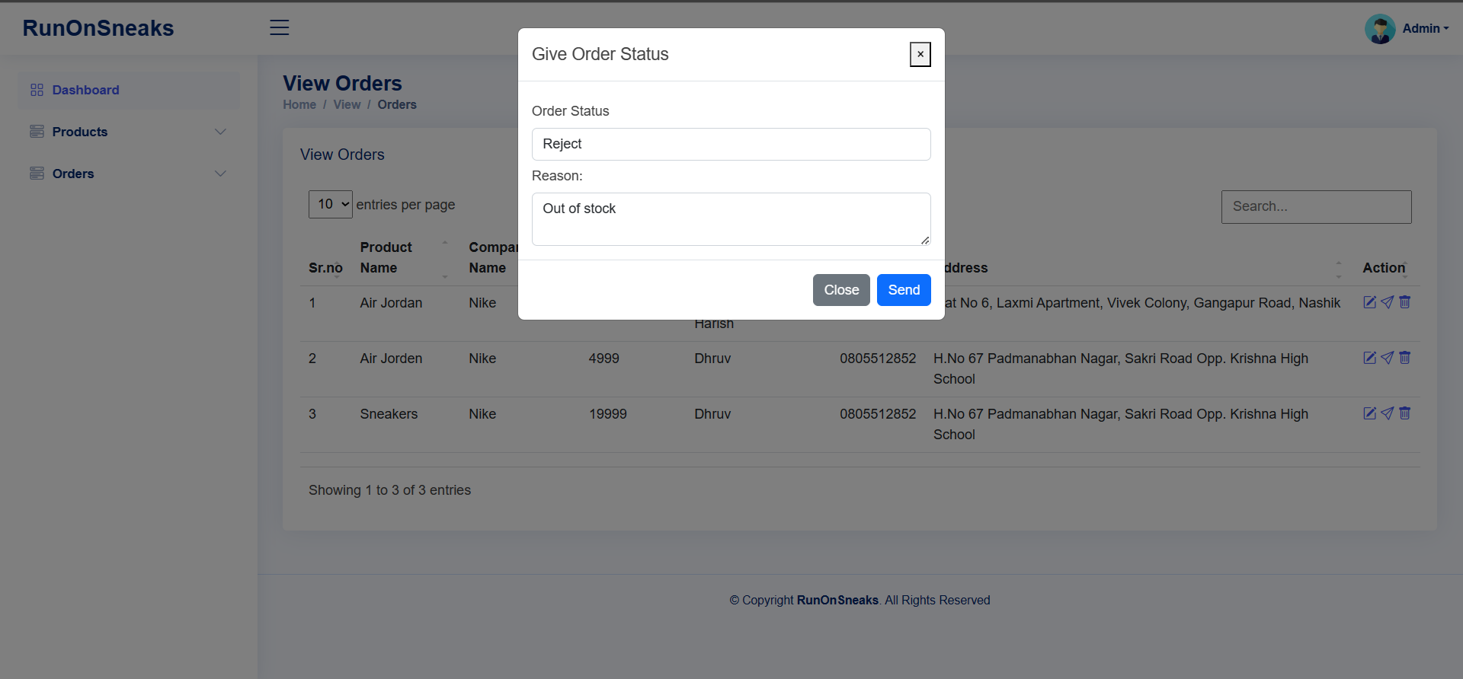

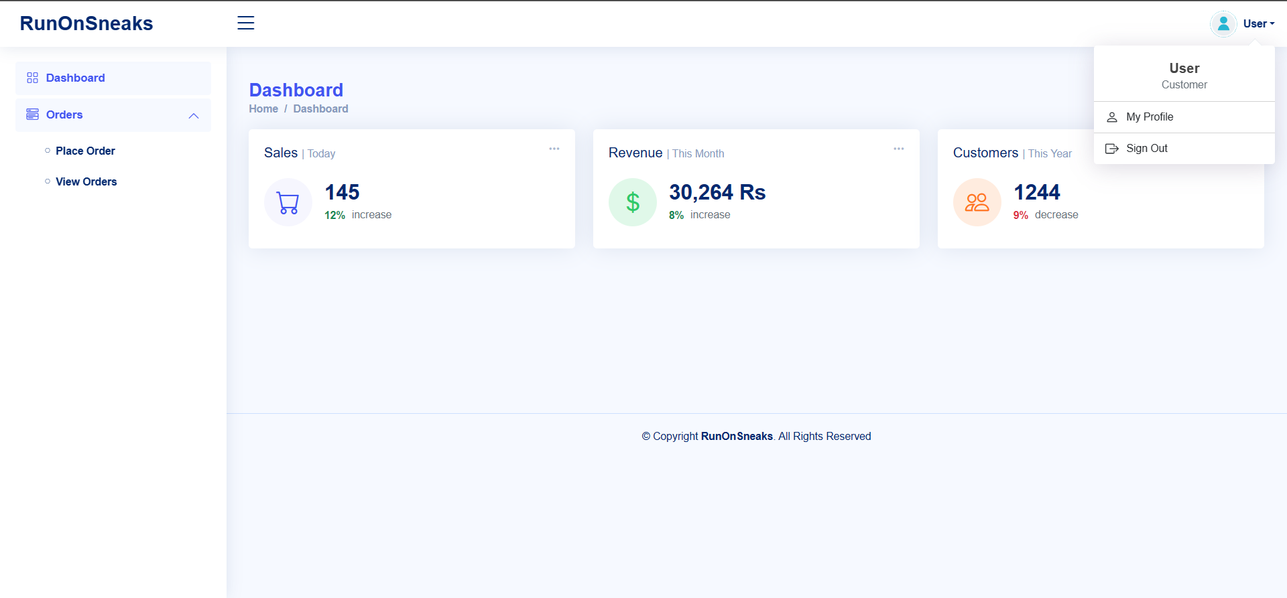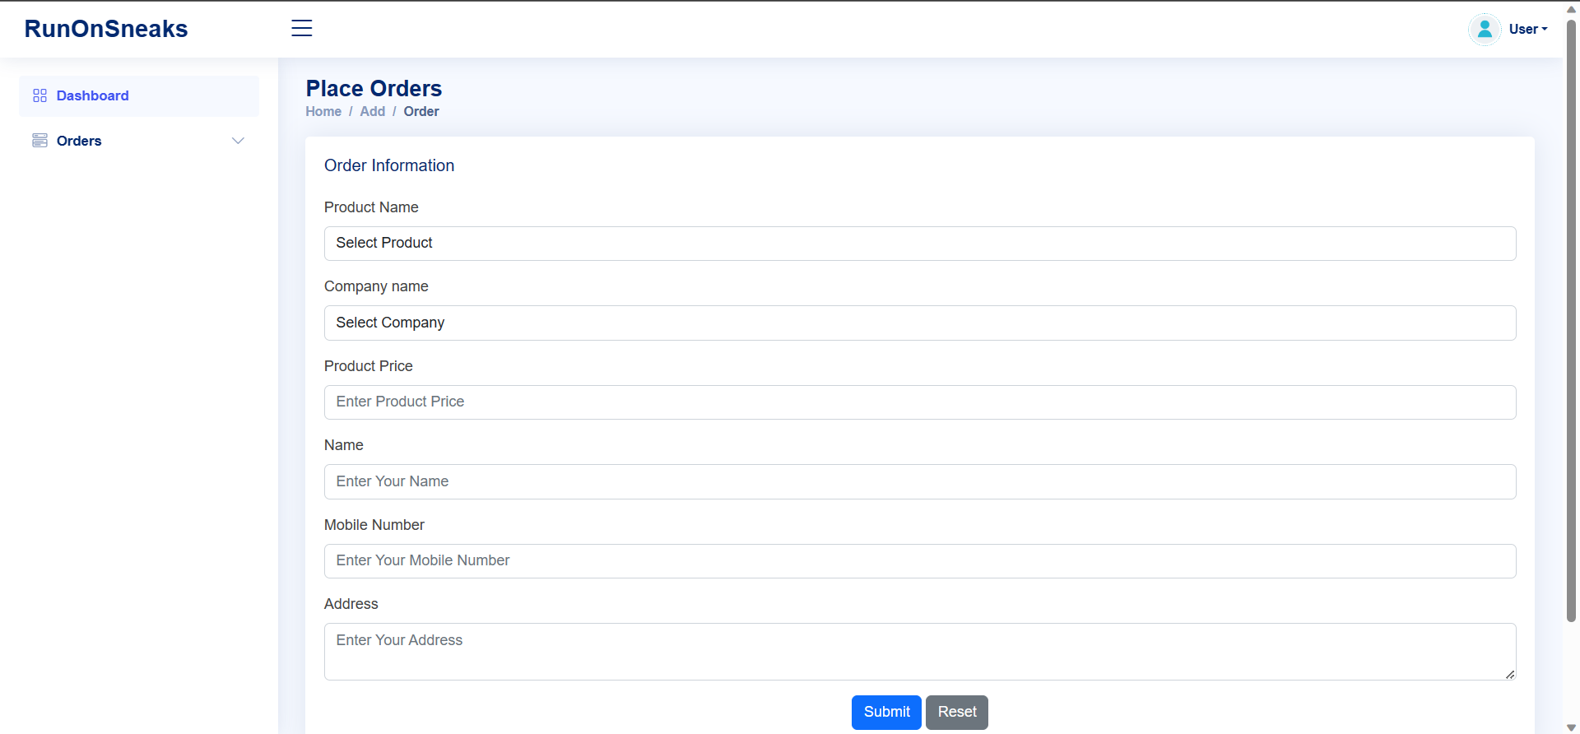

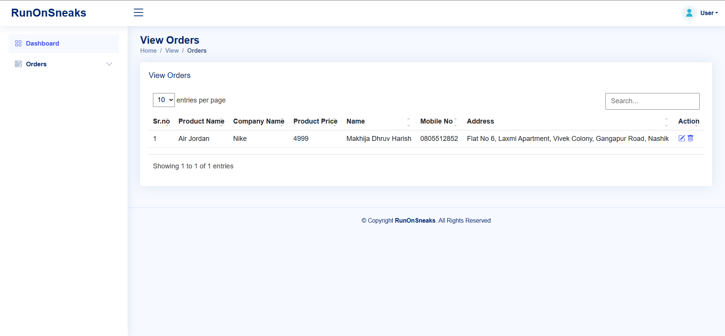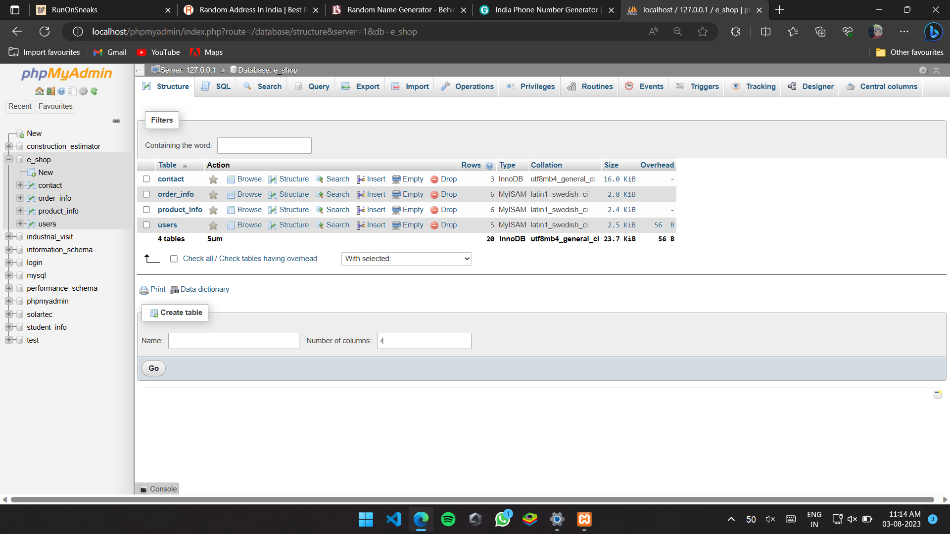

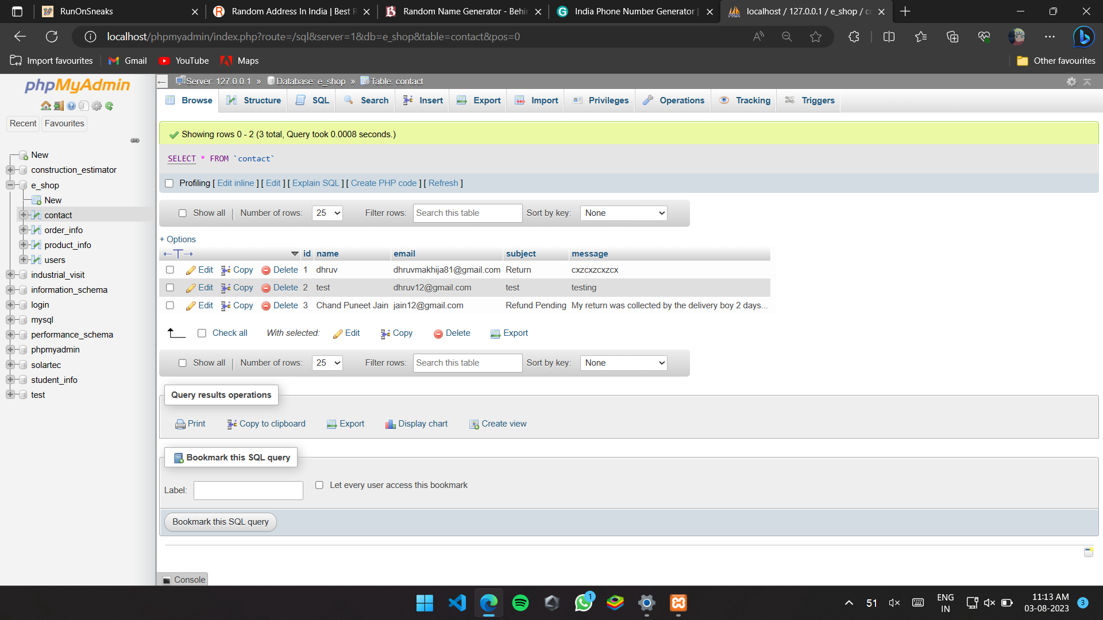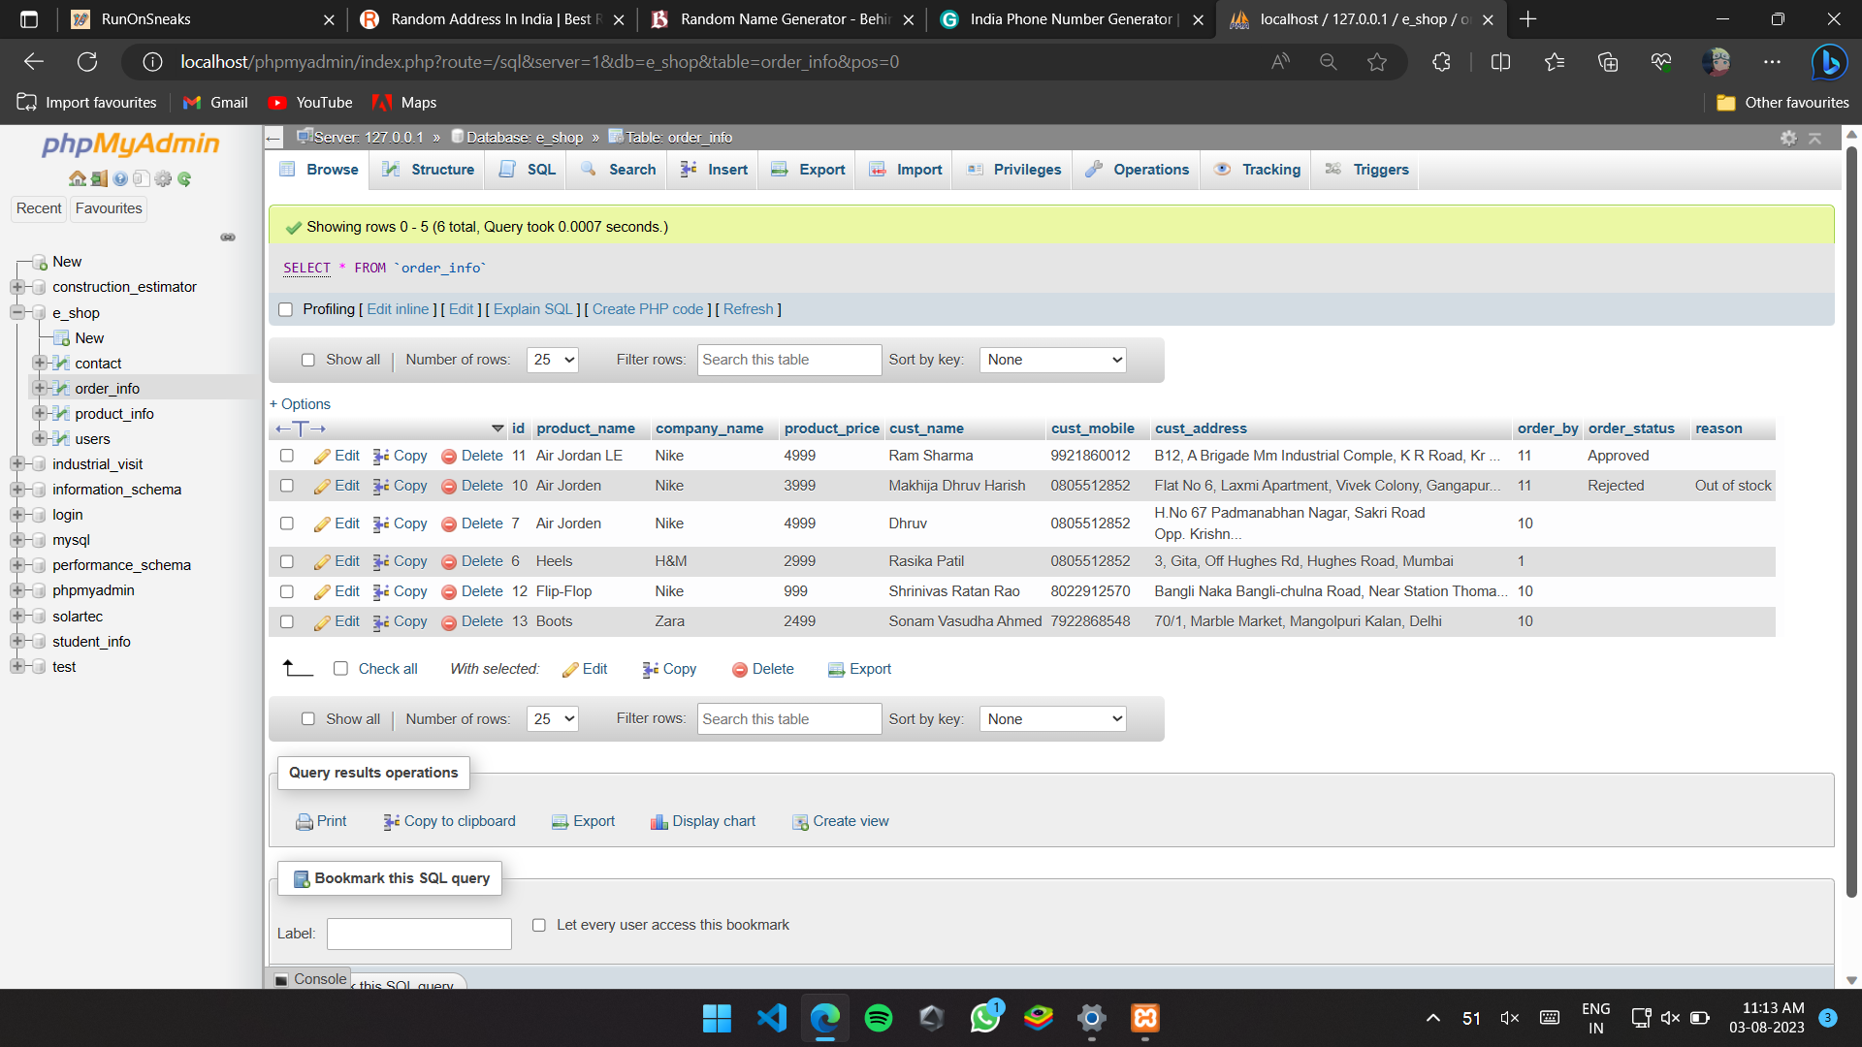

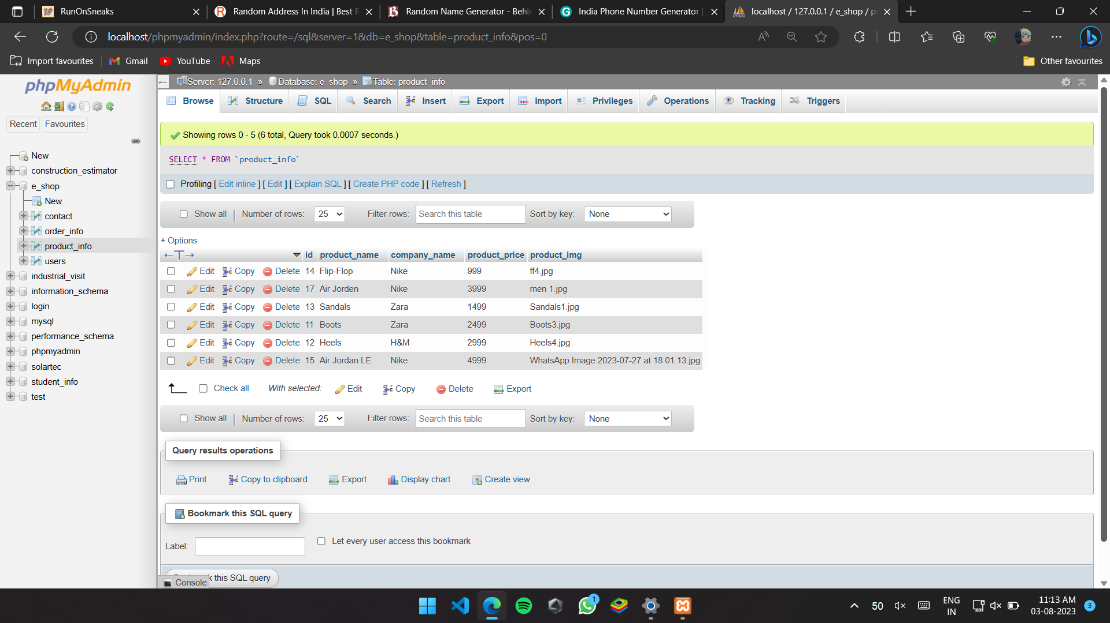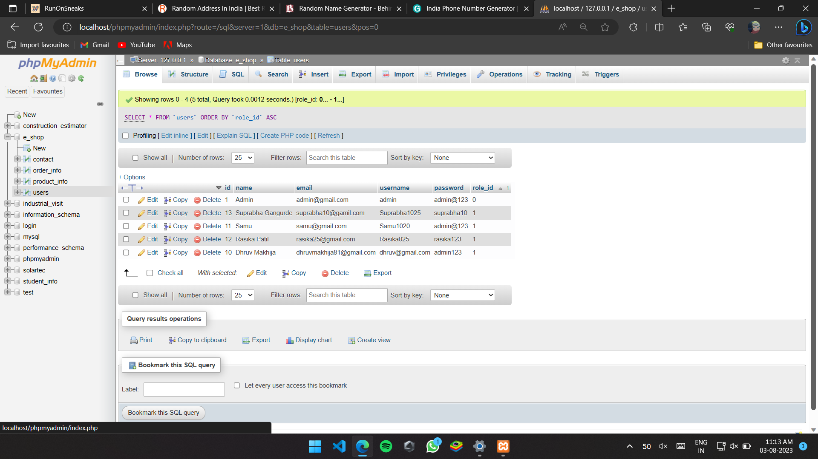

**Chapter 5**

**Findings & Suggestions**

1. **Findings:**

* Be able to complete a job or assignment given by the employer well and successfully.
* During the training period, we were exposed to an environment that is professional in identifying the tasks of workers. From there, we can see how a programmer may play a role.
* All the staff have their own duties in carrying out the tasks listed. This situation has helped us to work smoothly and always ask when we were in trouble. If we encounter any problems in the work done, other staff will also be able to assist us as well as provide valuable and helpful guidance for us because their willingness to share experiences and knowledge. Additionally, we always try to assist all staff and ensure that all work is done smoothly and in order.

1. **Suggestions:**

* Companies or firms also play an important role in providing students with guidance on what's appropriate with the courses learned by students. Hence the firm should also provide any form of reward for the work done by them. With the rewards or effective guidance from the firm itself can inspire the spirit of the student and can also attract them to the field.
* The company should avoid giving different directions to students. This is because students will feel confused when getting different instructions from different staff. The mistakes in the assignment can be avoided if the company provides correct and accurate instruction

**Chapter 6**

**Conclusion**

After undergoing 6 weeks of industrial training at InnovationsHub Services Pvt.Ltd, There is lot of new knowledge that can be learned and we got to understand altogether on how this firm plays an important role in industrial field, especially in Quantity Surveying. Exposure that have been given to us by InnovationsHub Services Pvt.Ltd staff about the working and technical aspect is a very meaningful knowledge to us in order to prepare ourselves before stepping into the real work environment on the upcoming days. I hope with the implication of the Industrial Training, there will be no more anomalous feelings when the students start working after they have finished their course later. The staffs at InnovationsHub Services Pvt.Ltd are very helpful and friendly. They gave us a lot of exposure on the terms of reference and procedures related to the process of our work. Other than that, the exposure visiting the other InnovationsHub Services Pvt.Ltd meeting atmosphere and so on also give a useful knowledge to us. Exposures that were given to us at this firm can provide the picture on a real-life situation, the task and responsibility that would be carried by some people on the field. Lastly, student’s involvement in industrial training like this can prove and further strengthen student's identity in undergoing training in technical field, in the same time making Polytechnic as practical platform of education. Apart from that, the format report that needs to be done by students after undergoing industrial training also can train each of the students in preparing technical report that is complete, compact and in a right order that can be made as an important knowledge when they face a real situation later. This is fit with the Polytechnic objective that is to produce a work